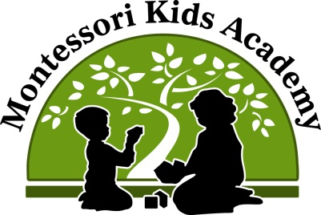

Ancient Civilizations Summer Camp
Bringing the Past to the Present

Summer camp is rapidly approaching! We have a fabulous curriculum that will lead the students on an adventure while they learn about the different ancient civilizations. While at camp, the students will continue with Montessori Language Arts and Mathematics lessons. During the work cycle, the students will work with the traditional Montessori materials and lessons. In Language Arts, they will continue to work on letter sounds, beginning sounds, sandpaper letters, the moveable alphabet, and phonics materials. In mathematics, they will explore numbers, sequencing, the four operations, shapes, and sizes. There will be daily handwriting practice as well as fine motor development. Each week’s theme will bring new excitement to the students as they count using Egyptian artifacts, add using rocks from a volcano, and subtract using African animals. They will learn how to read words from the ancient Chinese and match letters and words in Mayan hieroglyphs. We will also do daily art projects that will develop fine motor control as well cultivate creativity.
In addition to the academic aspect of the camp, the students will also have different enrichments. Each week will include an art enrichment, daily arts and crafts, a cooking enrichment, water park play and a field trip. Each Friday the ice cream truck will visit the school. There will also be an optional fabulous overnight camping adventure.
If you have any questions about the academic component of our summer camp, please feel free to stop by the front desk or speak to Ms. Tara. We are looking forward to going on this summer adventure with your child!

